Monitoring drug control strategies:
hidden phenomena and observable indicators

Carla Rossi
Department of Mathematics, University of Rome "Tor Vergata"
Rome, Italy

1. Introduction.

Drug policy implementation needs to be evaluated, to set up more efficient strategies and to forecast future service needs.
Policy makers and researchers are seeking answers to a number of questions concerning drug use, its consequences and related costs. They focus on questions such as: ‘how much drug use?’, ‘what are the consequences of this use?’, which policies are effective?’, what are the costs of the policies and of the consequences?’. The consequences comprise, among many others, the adverse effect of infectious diseases and the costs imposed to society by the drug-related criminality. Programme monitoring answers the question: 'how is a given policy being implemented?' by analysing the current performance of a policy, helping to detect problems in successful achieving the policy’s objectives. An effective monitoring system provides information as to why a given policy is working or not and it must have the following characteristics:

- decision-oriented: designed to assist managers and policy makers in setting clear and attainable objectives;
- process oriented: providing data on actual programmes in progress;
- based on criterion of utility: providing the sort of information a manager can use;
- focussing on questions that reflect the short or medium term impact and short or medium term solutions;
- oriented toward resource limitations and tradeoffs, recognizing the need to direct responses to problems toward solutions that are in keeping with budgetary and other resource constraints.

Hence it is important to understand and “measure” drug use and how it responds to drug control interventions. However, since drug abuse is generally a stigmatized and hidden behaviour and is prosecuted in most countries, there have been varying degrees of underreporting when standard epidemiological survey techniques (such as US household survey of drug abuse) have been used. Thus, it is necessary to develop methods which allow to estimate the extent of the phenomenon from observational secondary data on drug abuse that are available in various forms. Estimation techniques mostly refer to models and methodologies to estimate the extent and the dynamics of drug abuse in a community and/or at the regional or national level based on various observed phenomena (secondary data) and on the information received from some target population. Secondary data can be defined as existing statistical and documentary information that is routinely collected and readily available, such as treatment presentations, drug seizures, infectious diseases indicators, or drug related deaths. To define the most suitable indicators, it is necessary to study the hidden phenomenon “illegal substance use and abuse” and to identify the observable indicators connected to that phenomenon and to the drug market to be included in an efficient information system on drug abuse.

2. Core Indicators of Drug Abuse - the Lisbon Consensus
A panel of technical experts representing international bodies and regional networks met in Lisbon in January 2000 to discuss the principles, structures and indicators necessary for effective drug information systems. The meeting was supported by the United Nations International Drug Control Programme (UNDCP) and hosted by the European Monitoring Centre on Drugs and Drug Addiction. At this meeting, participants considered the technical aspects of collecting reliable, accurate and strategically valuable information on drug abuse and identified the structures necessary to support the collection and analysis of data at the national, regional and global levels. Particular consideration was given to development of a set of core epidemiological demand indicators against which Member States could report on their respective situations. The following list of core indicators represents the consensus expressed by the technical experts at the meeting:
- Drug consumption among the general population
(estimates of prevalence and incidence)
- Drug consumption among the youth population
(estimates of prevalence and incidence)
- High-risk drug abuse
(estimates of number of drug injectors and proportion engaging in high-risk behaviours, estimates of the number of daily users)
- Service utilization for drug problems
(number of individuals seeking help for a drug problem)
- Drug-related morbidity
(HIV, HBV and HCV prevalence among illicit drug consumers)
- Drug-related mortality
(deaths directly attributable to drug consumption)
The above mentioned indicators, though only intended to measuring drug abuse, can also be used to measure drug production and trafficking according to the statistical relationship found between these two phenomena. Such relationship is clearly reported in the UNODCPP World Drug Report 2000 Box 1A where seizure statistics are found to be highly correlated (correlation coefficients about 0.95) both to consumpion statistics, such as prevalence of use and drug related mortality, and production statistics. Thus, various different indicators, related to both supply side or demand side, can be alternatively, or simultaneously, used to measure the extent and trends in order to evaluate the implemented policy.

3. Some examples.

According to the World Drug Report 2000, the higher the seizures, the higher the production and the prevalence of abuse. Thus, the so called interception rate is essentially constant. The following map shows recent trends in trafficking and production statistics (ODCCP Illicit Drug Trends 2002).
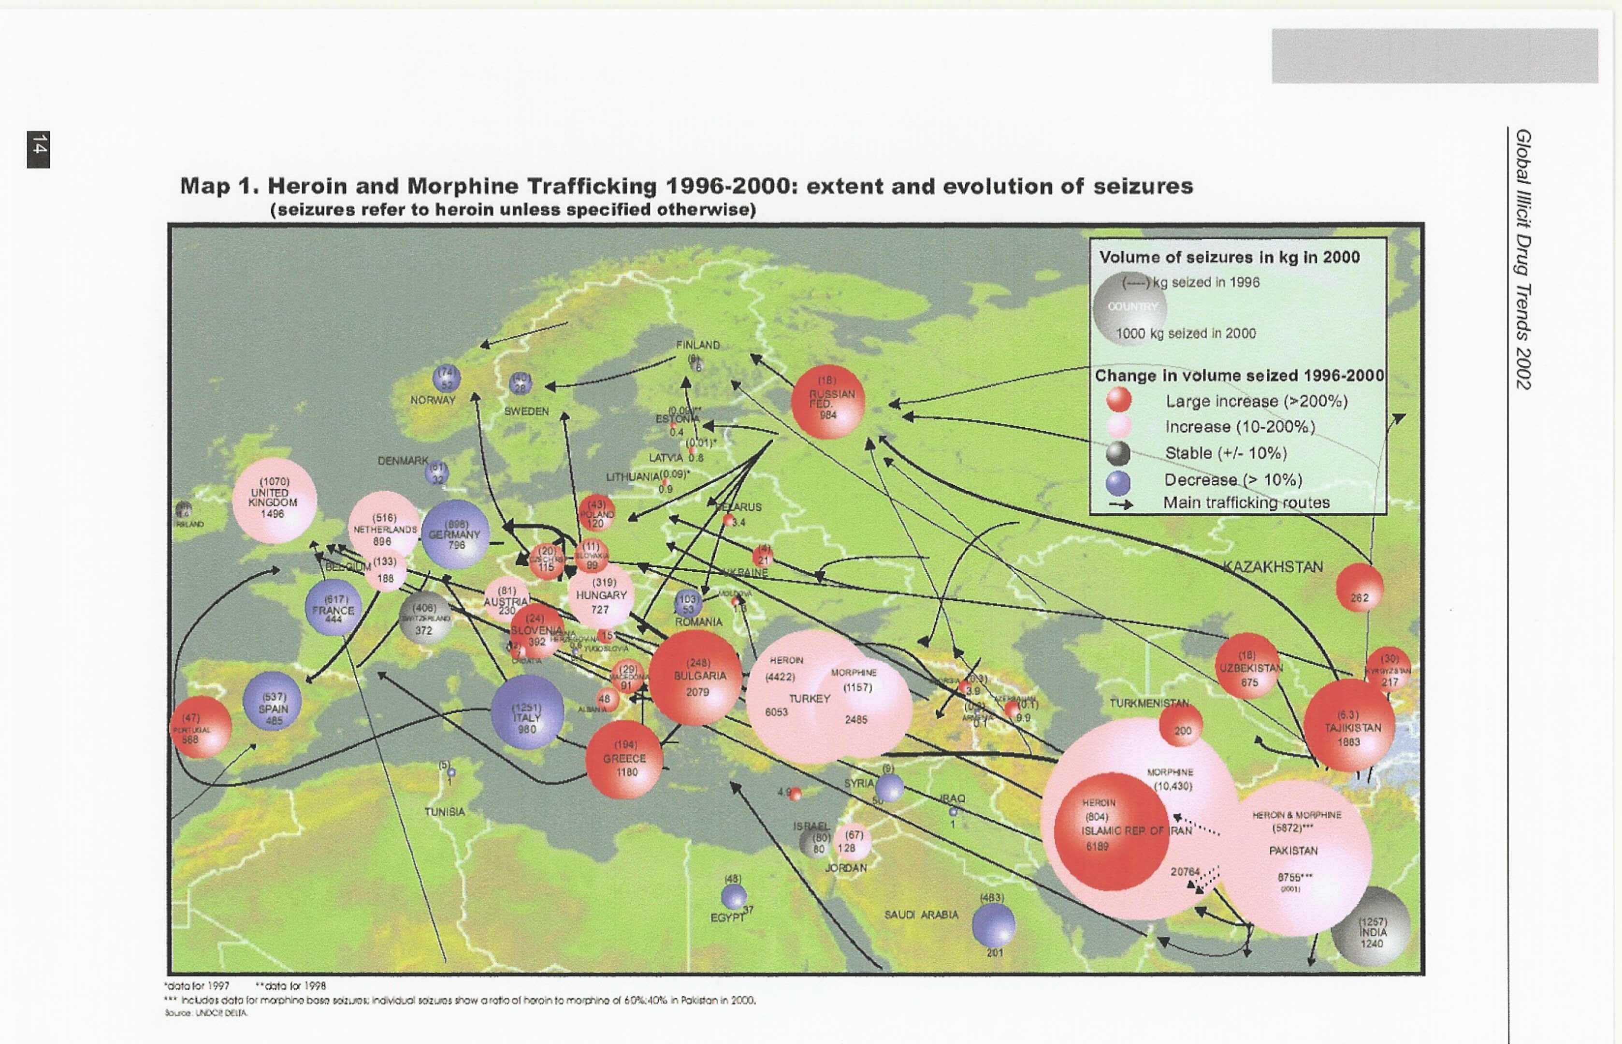
The map shows that trafficking in heroin and morphine is largely increasing in Asia and eastern Europe in recent years.In western Europe some decrease is evident. In other words, new markets are expanding in eastern countries due to saturation of old markets in the western countries. Globally the trafficking indicators show an overall increase, even considering 99/2000.
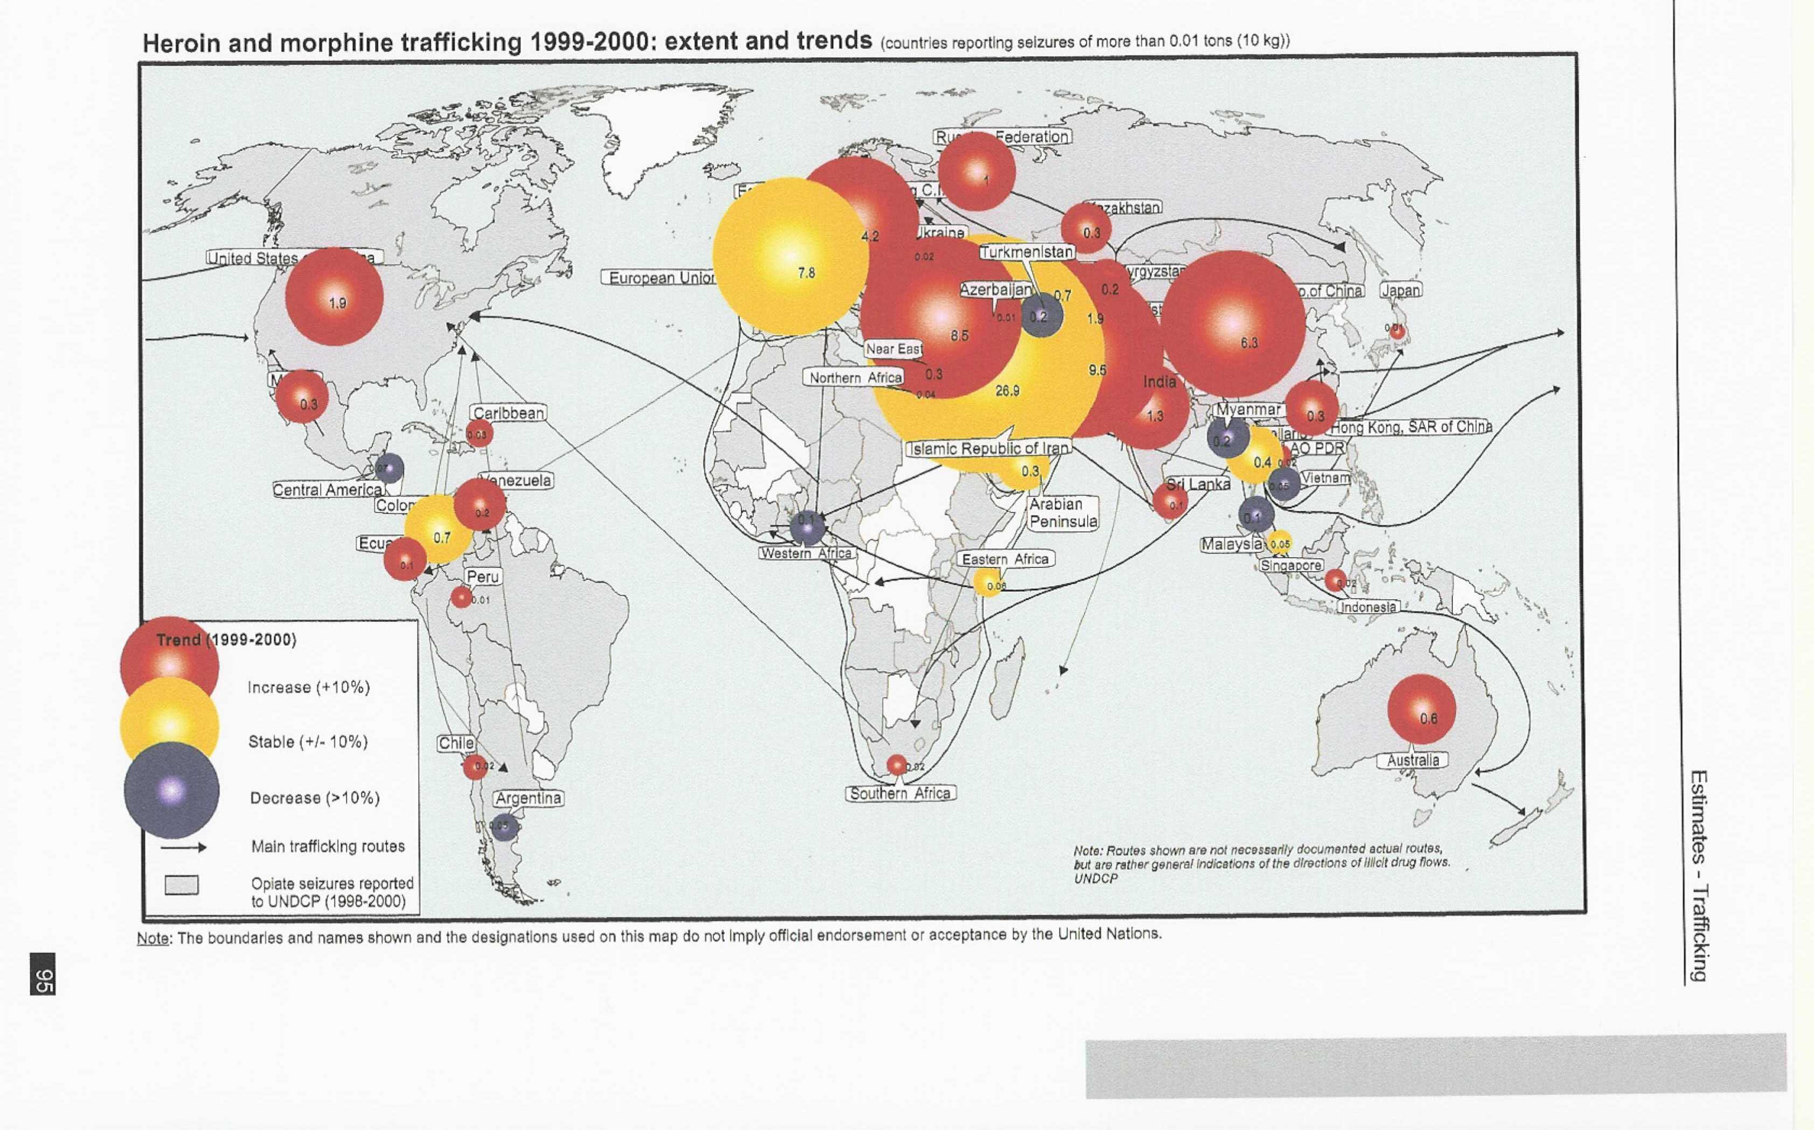
The general situation is quite the same for other substances such as cocaine, amphetamines….

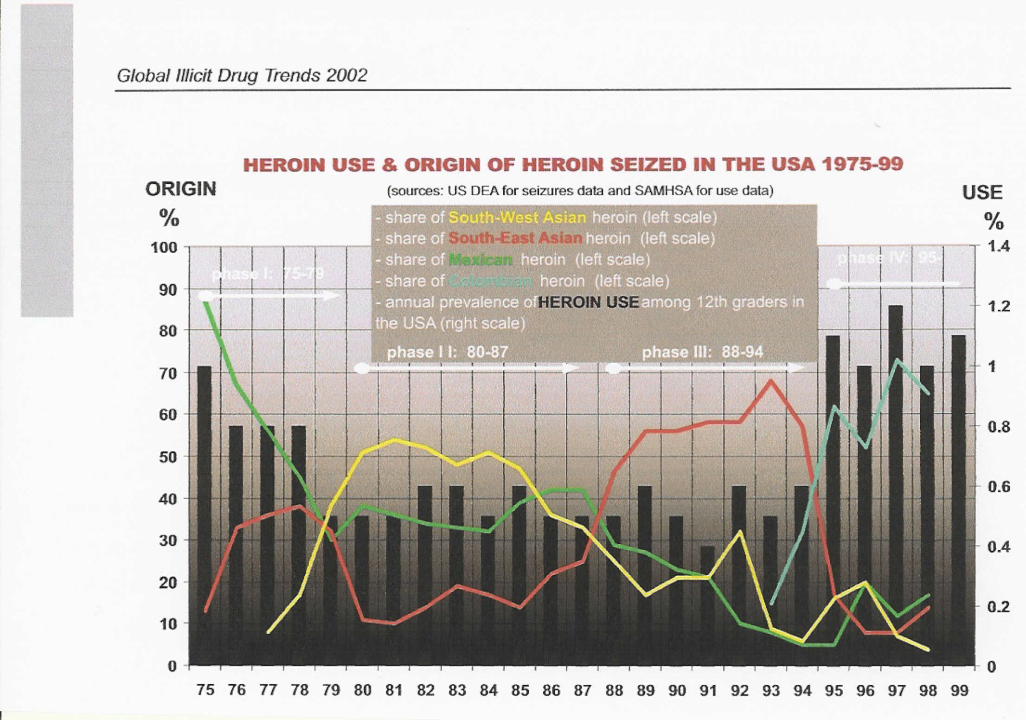
But, not only new markets replace saturated markets, also new producer countries replace old producer contries, showing an overall expansion, as it is reported in the graph reported above.
Drug abuse is increasing too and different substances are spreading in different areas following the market trends. In particular, heroin is spreading in the eastern areas, cocaine in the western ones.
Globally all the substances are spreading.
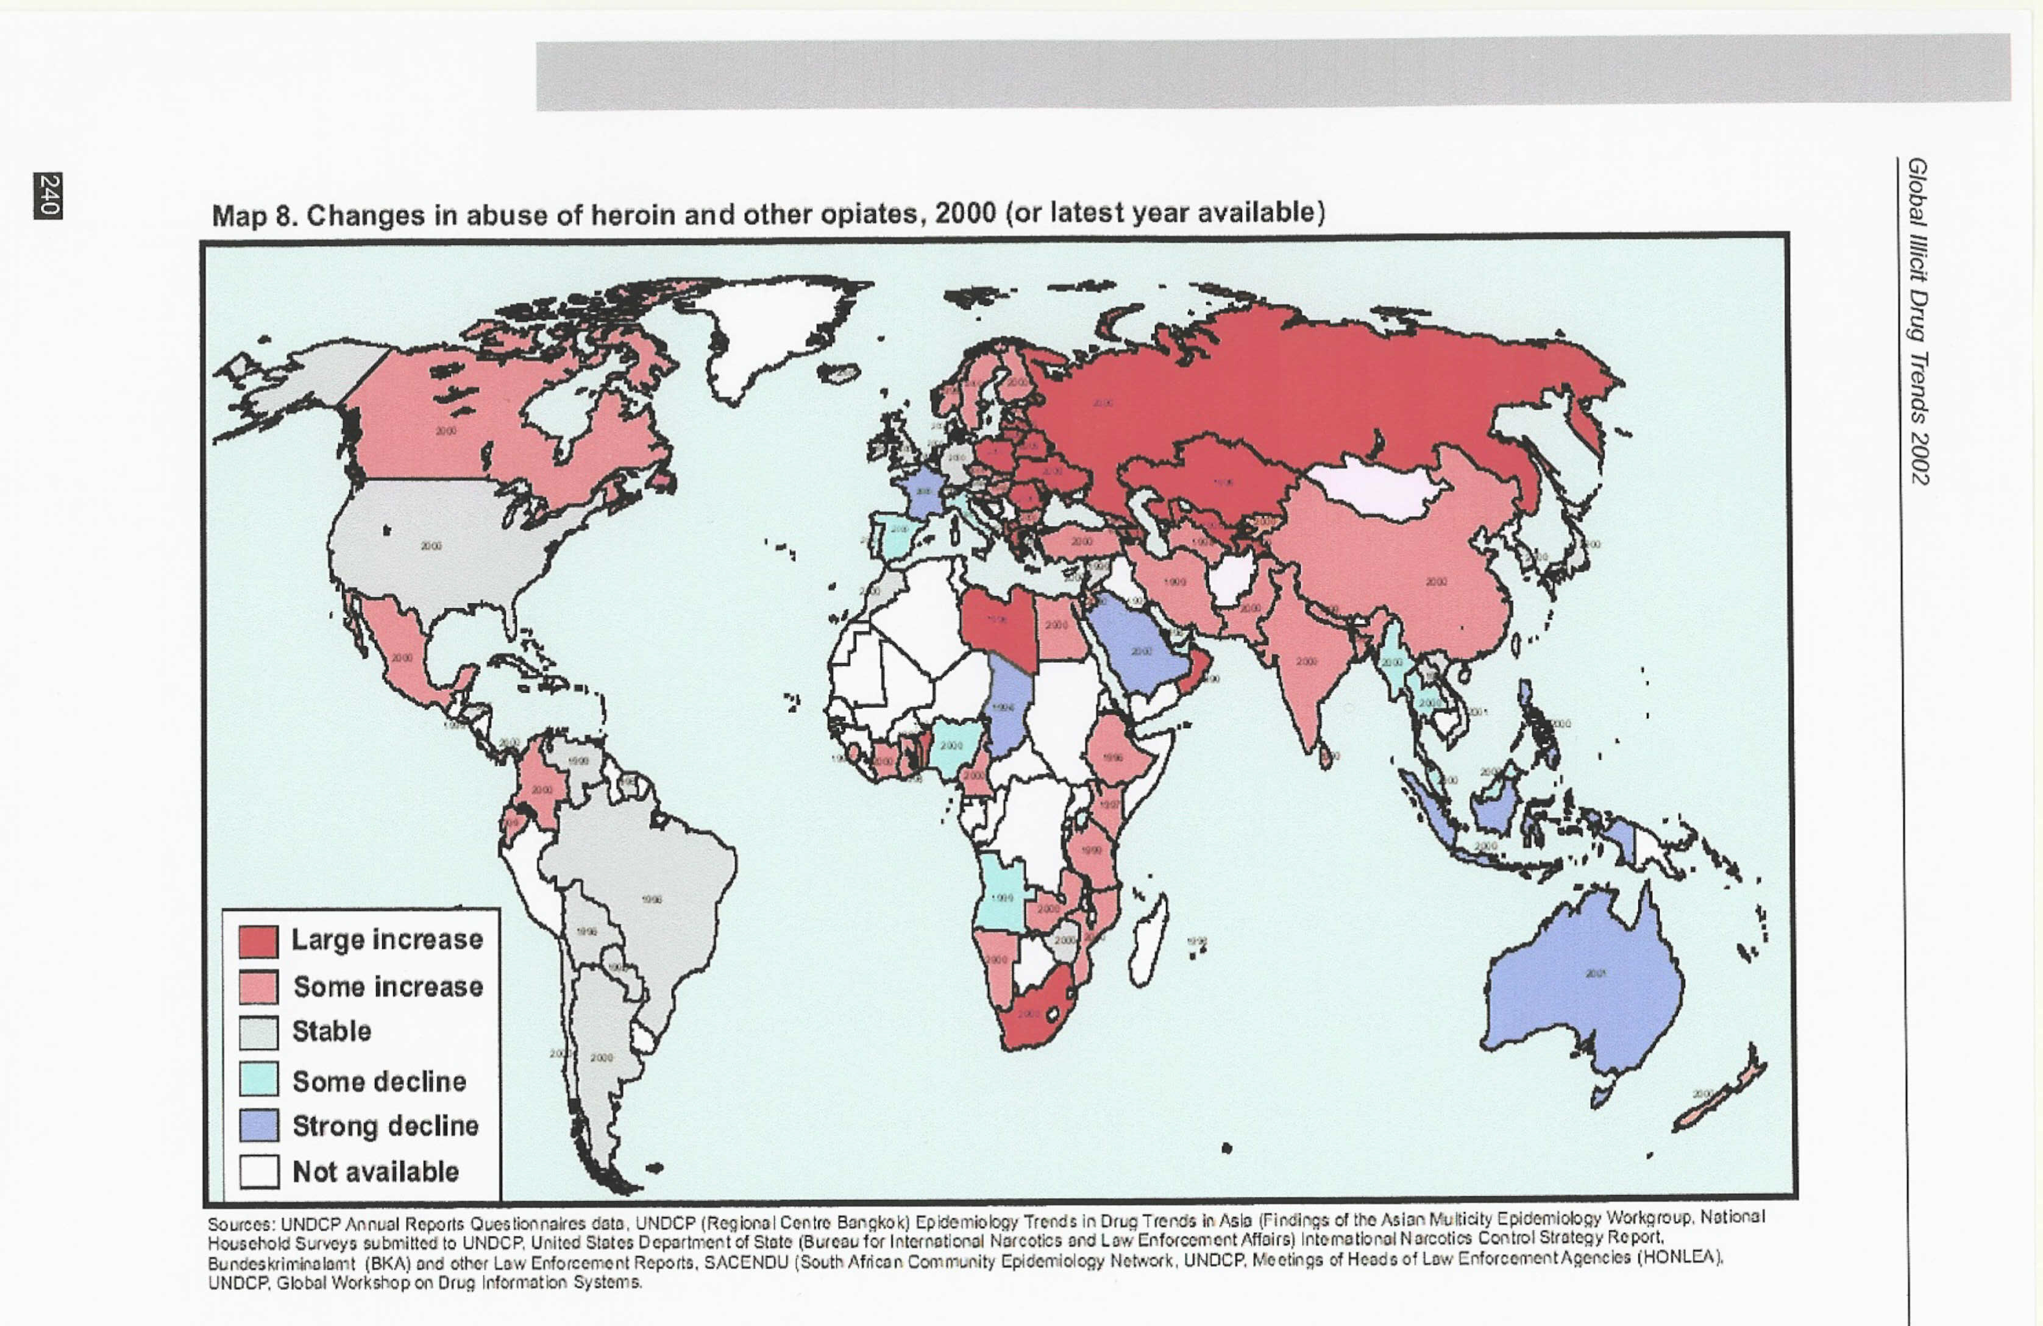
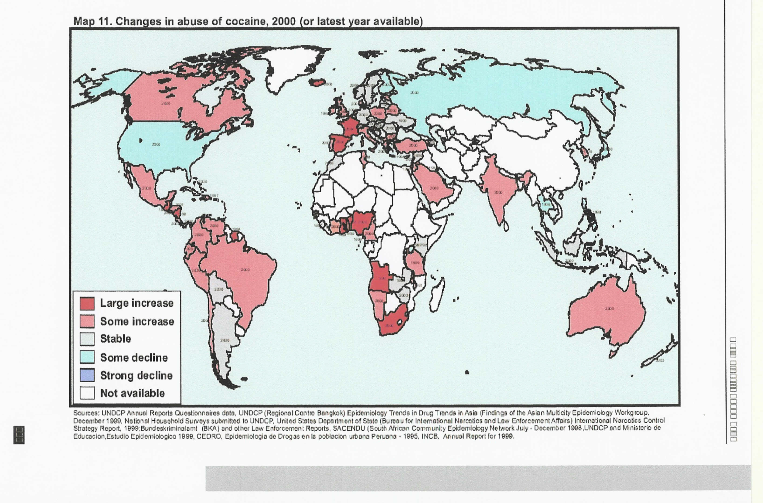
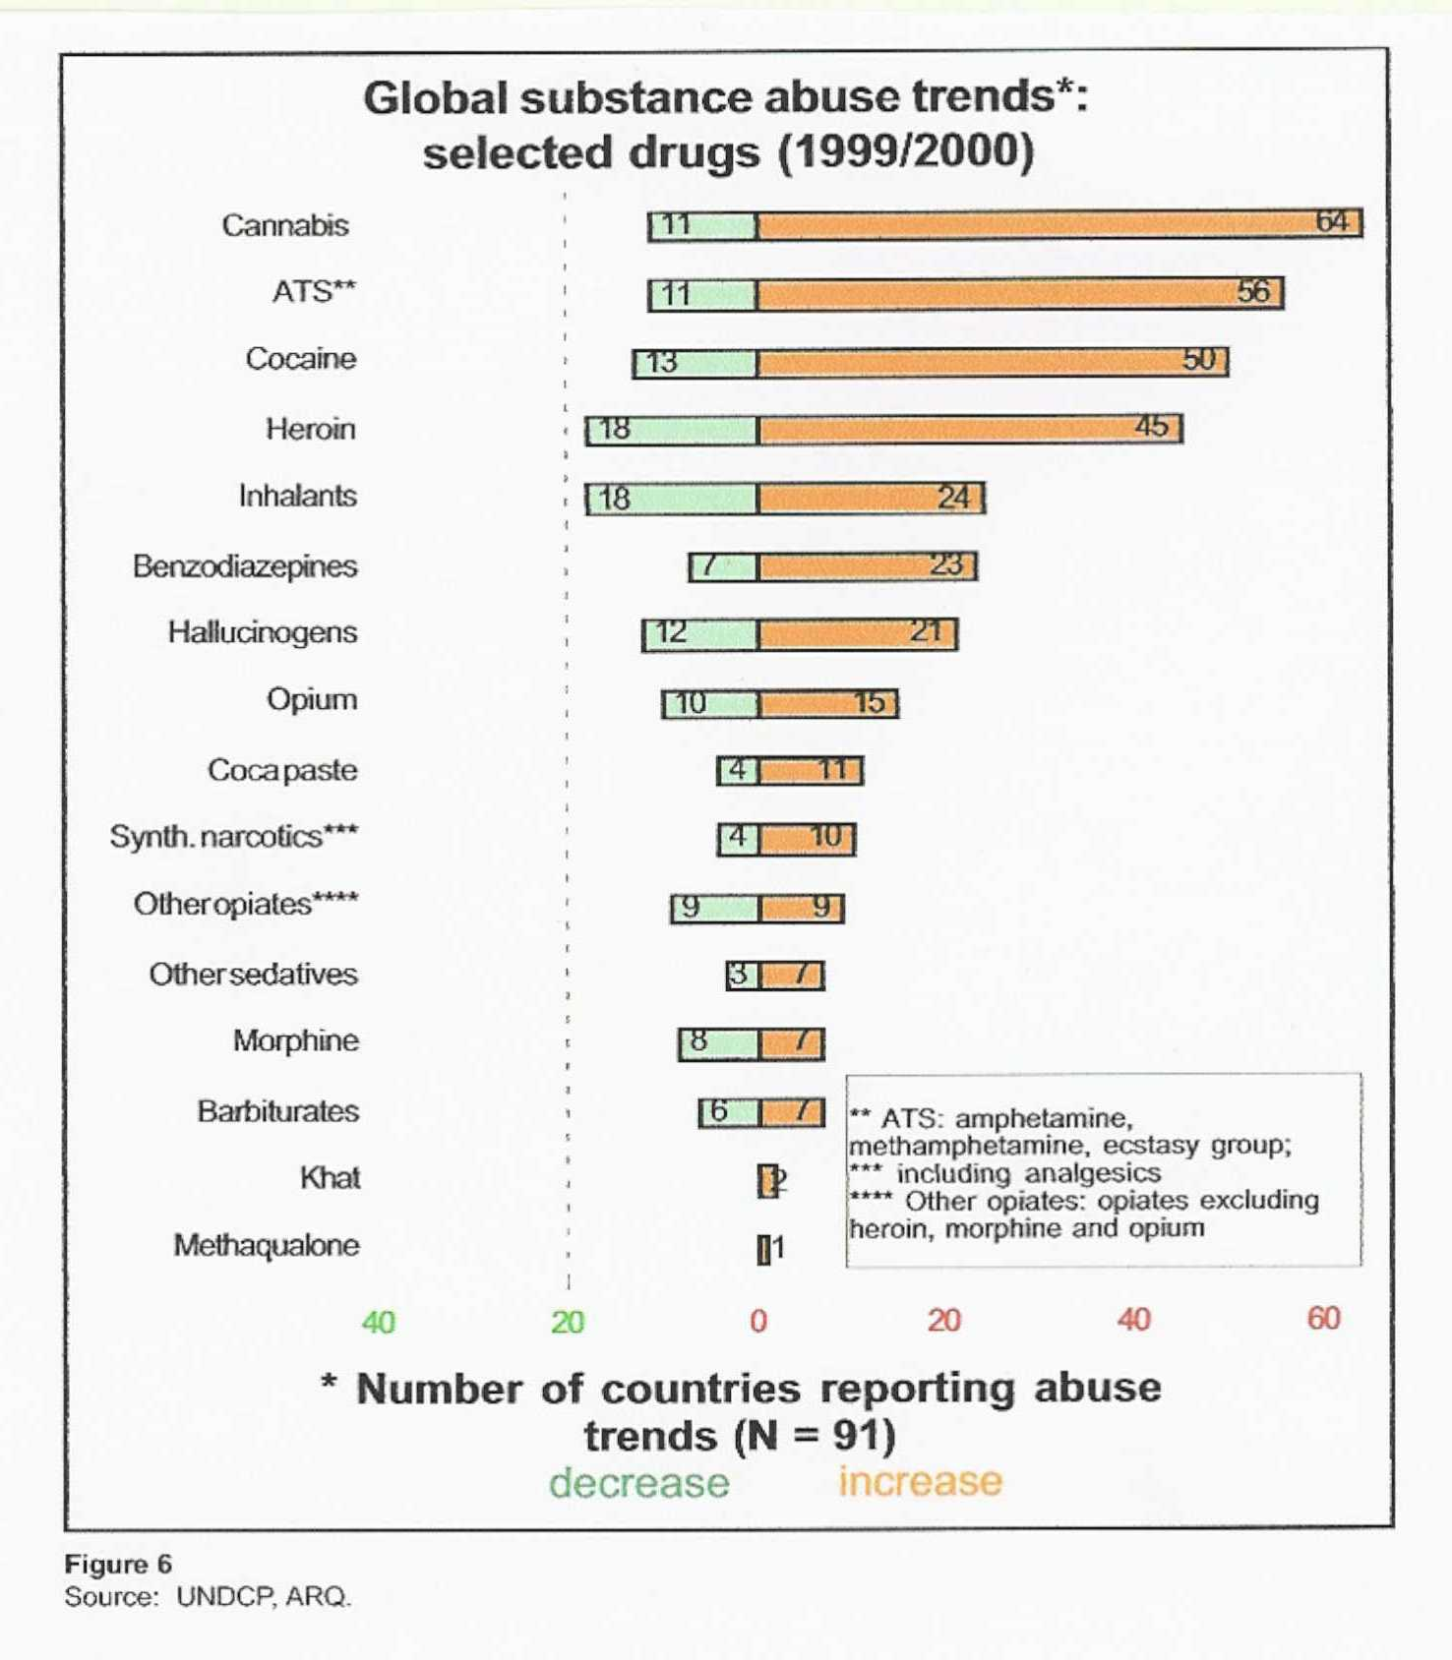
Considering the data provided by UN (Global Illicit Drug Trends 2002 and World Drug Report 2000) it appears that Drug markets are expanding, colonizing new countries and introducing new substances. Drug abuse is expanding as well, even among youths. Trends are not in agreement with the UN goal of eliminating drugs by 2008.

Understanding the level of drug consumption in any population is often the starting point for policy discussions. Generating general population prevalence and incidence estimates is therefore a key task of most drug information systems. Attention is often focused on prevalence estimation. However, incidence (new cases) levels are likely to be equally important for informing policy formation. In respect to both prevalence and incidence estimation it should be noted that this area does not lend itself to any single methodological solution. Whilst surveys provide one method for achieving estimates in this area, other estimation methods also exist, such as data from sentinel surveillance systems and indirect statistical estimation techniques. In many countries conducting national prevalence surveys may be currently not possible for reasons of cost, or because of methodological or practical difficulties.
Both because drug consumption among young people is often a particular concern of policy makers, and because age cohorts of young people make a convenient sampling unit, estimates of drug consumption among the youth population form an important part of many drug information systems. School surveys have been used extensively to generate estimates in this area. However, because school attendance patterns vary between countries, and because surveys may exclude important sections of the youth population, other methods may be utilized.
Some drug taking behaviors are particularly associated with severe problems and as such merit attention. The most common data collected in this area are, the numbers of drug injectors, and the dependent= or very frequent users of drugs. Specific methods are needed to gain information on behaviours like injection as their hidden nature and low prevalence usually mean that they are poorly covered by general population estimates. In respect to drug injection and the transmission of infectious agents it is also necessary to collect information on rates of high risk injecting behaviours (equipment sharing).
Drug treatment registers are often used as a proxy indicator of treatment demand. This information is useful for analysis of service utilization and can be used as an indicator of trends in prevalence and patterns of high-risk drug consumption. These drug treatment registries may not be appropriate where general health and social services are the main providers of help. It should be remembered that across countries the scale, structure, and nature of services for those with drug problems vary greatly. Therefore, definitional clarity is particularly important in service utilization reporting, as is an understanding of the methodological and analytical issues pertinent to drawing conclusions from service populations to drug problems among the general population.
Health costs are of obvious importance in informing policy development with regard to illicit drug consumption. Common measures include drug-related infections such as HIV, Hepatitis B, and Hepatitis C, and behavioural risk factors, among drug injectors. Conceptual problems do exist in this area and further development work is required. In particular, problems exist in estimating the contribution that drug consumption has made to cases of disease in which there are other additional attributed causes, and in calculating the proportion of cases in which drug use is the sole attributed cause when a number of possible causes exist.
The number of deaths attributable to drug use is of obvious strategic importance to policy makers. However, considerable methodological and practical problems exist in compiling and comparing this information and further development work is required. As with morbidity it is important to distinguish between those deaths which are solely attributable to drug consumption, (such as drug overdose), those where drug consumption is attributable for a proportion of deaths (such as AIDS deaths), and those deaths where drug use is one of several attributable factors. These definitional problems mean that the use of different data sources and methods is required if reliable and comprehensive data on drug mortality is to be collected.

